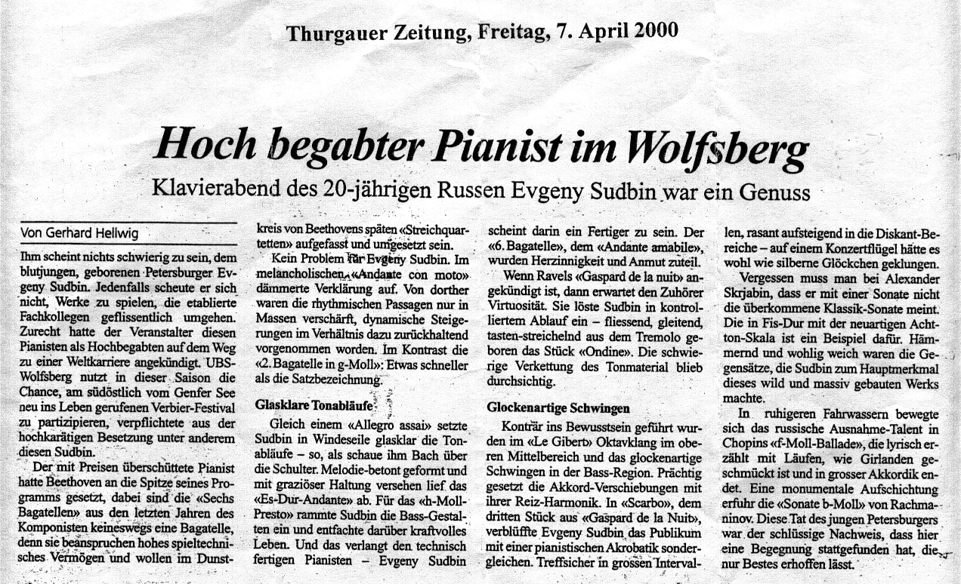
translation:
Highly talented pianist in Wolfsberg
Recital of the 20-year old Russian Evgeny Sudbin was a real treat

Nothing seems to be of any  difficulty for the young Evgeny Sudbin, in  who was born in St.Petersburg.  In any case, he had the nerves  to play works which are deliberately  avoided by his already established  colleagues. The organizers were  absolutely justified in proclaiming that  this pianist is well on the way to  a successful international career.  This season, UBS-Wolfsberg uses  the chance to participate in the Verbier  Festival and engaged Sudbin as  one of their highly valued artists.  The pianist, already overwhelmed  with prizes, put Beethoven at the top  of his programme. Yet the  Six Bagatelles, from the composer’s  last years, are under no circumstances  mere bagatelles as such, as they require  a highly accomplished pianistic  ability, and need to be comprehended  within the context of Beethoven’s  late string-quartets. | No problem for Evgeny Sudbin. In the melancholic Andante con moto, he projected the ideal purity of the movement in balanced contrast with the rhythmic passages and rising dynamics.  In contrast to the 1st Bagatelle, the 2nd in G minor was a little faster than the movement’s marking.  crystal-clear passages  Sudbin articulated the passages in a crystal-clear manner as if Bach himself was looking over his shoulder. The Andante was well formed with melodic emphasis and a graceful style.  For the B minor Bagatelle,  Sudbin accented the bass line  and brought a spark of powerful  life into the work. And in  this area, the technically  complete pianist Evgeny Sudbin  seems to be fully accomplished. | In the Andante amabile, Evgeny communicated emotional depth and charm.  Whenever Ravel’s Gaspard de la Nuit is announced, then the audience is naturally prepared for some virtuosity. Ondine emerged from the tremolo, in a glidingly smooth and fluent manner. The difficult interweaving of material always remained transparent.  bell-like vibrations  On the contrary, Gibet’s sound of octaves and the bell-like tolls in the bass were slowly introduced to audience’s mind. The chord-shifts with their jangling harmonies were magnificently played. In Scarbo, Evgeny dazzled the audience with pianistic fire-works of a rare kind.  The ascending rapid passages in wide intervals were always clean and secure. | One has to forget that Alexander Scriabin doesn’t have in mind the classic form of sonata. His 5th Sonata, with the inventive 8-tone scale, is an example of that. Hammering and beautifully tender were the conflicting characteristics of this piece, which Sudbin made the main feature of this wild and massive work.  In the F minor Ballade on the contrary, the Russian outstanding talent was moving into calmer waters. Lyrically narrated, with passages smooth and bedecked as if with garland, Sudbin ended the Ballade with rich-coloured chords.  A monumental accumulation  of musical material brought  forth Rachmaninov’s B minor  Sonata. What this young  Russian did was the ultimate  proof, that what the audience  had encountered here, allows us  to hope for only the best.

