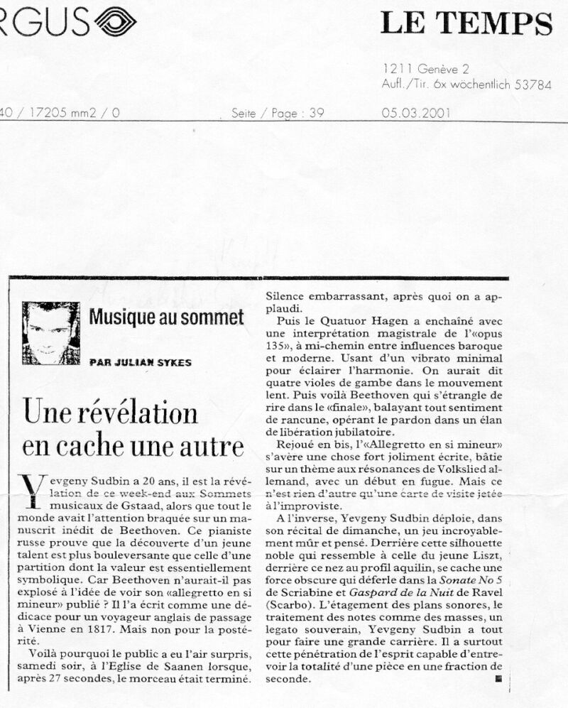
Translation from:

Le Temps 05.03.2001
Music-summit

One discovery is concealed by another

Yevgeny Sudbin is 20 years of age; he is the true revelation of the music festival Les Sommets Musicaux de Gstaad this weekend, even though everyone’s attention was turned towards Beethoven’s unpublished manuscript. This Russian pianist proves that the discovery of a young talent is more stunning than that of a lost manuscript, whose value is mainly symbolic.
...
On the contrary, Yevgeny displayed unbelievably mature and thoughtful playing in his recital. Somewhere behind that noble silhouette which reminds one of the young Liszt, behind that nose of aquiline profile, broods a dark force which unfolds during the 5th Sonata by Scriabin and Ravel’s Gaspard de la Nuit (Scarbo). Gradation of sound-palette, treatment of single notes as a mass formation, achieving supreme legato; Yevgeny Sudbin has everything to make a great career. He particularly has this ability of penetrative insight that enables him to have the vision of a piece in its entirety in just a split second.

