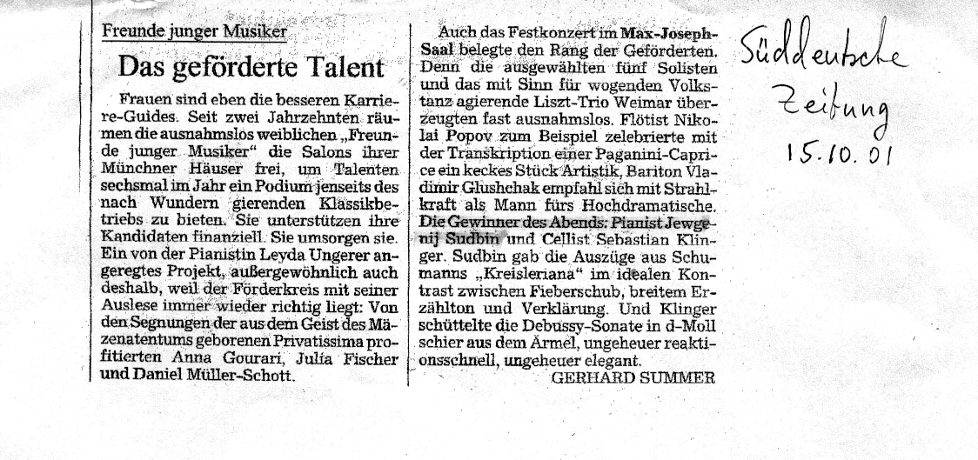

Translation from Sueddeutsche Zeitung:

15.10.01
…
The favorites of the evening in
tonight’s concert were undoubtedly
pianist Yevgeny Sudbin and cellist
S. Klinger. Sudbin established in
Schumann’s Kreisleriana an ideal
contrast between the feverish musical
thrust, broad narrative tone and
transcendental expression.

