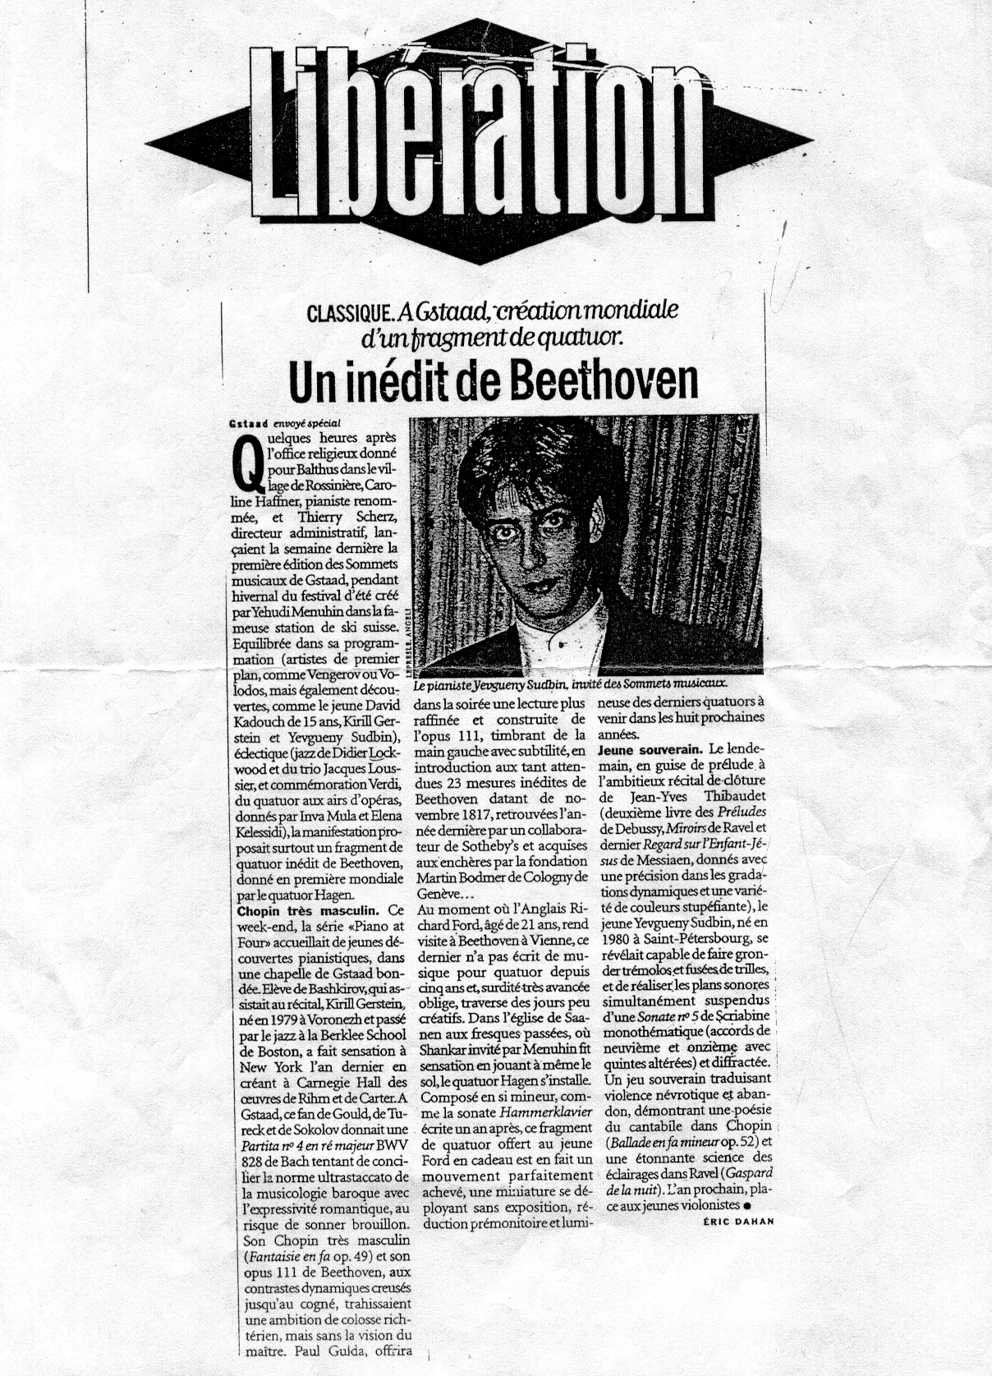

Translation:

Tuesday, the 6th of March 2001

… the youthful Yevgeny Sudbin, born in 1980 in St. Petersburg, revealed his ability to thunder out tremolos and trills like gun fires, to achieve different levels of sonority which are suspended simultaneously in the monothematic (chords with added 9ths and 11ths) and segmented Sonata No 5 of Scriabin.
Sovereign playing which transmits nervous power and full abandon in Scriabin, revealing lyrical poeticism in Chopin’s Ballade No 4 and an astonishing capability of elucidation in Gaspard de la Nuit by Ravel.

