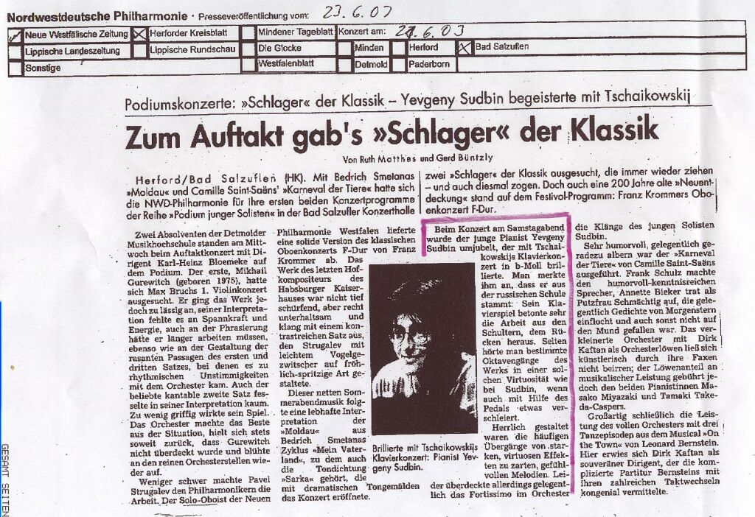

translation:
…
At the concert on Saturday evening the young pianist Yevgeny Sudbin was feted by the audience after his brilliant performance of Tchaikovsky’s 1st Piano Concerto. One could tell that he has his roots in the Russian piano school: his playing very much bore the emphasis of working from the back and shoulders. Rarely has one heard certain of the octave passages played with such virtuosity as by Sudbin, even if somewhat veiled by the pedal. Wonderfully shaped were the frequent transitions from strong, virtuoso effects to tender, emotional melodic motifs.

