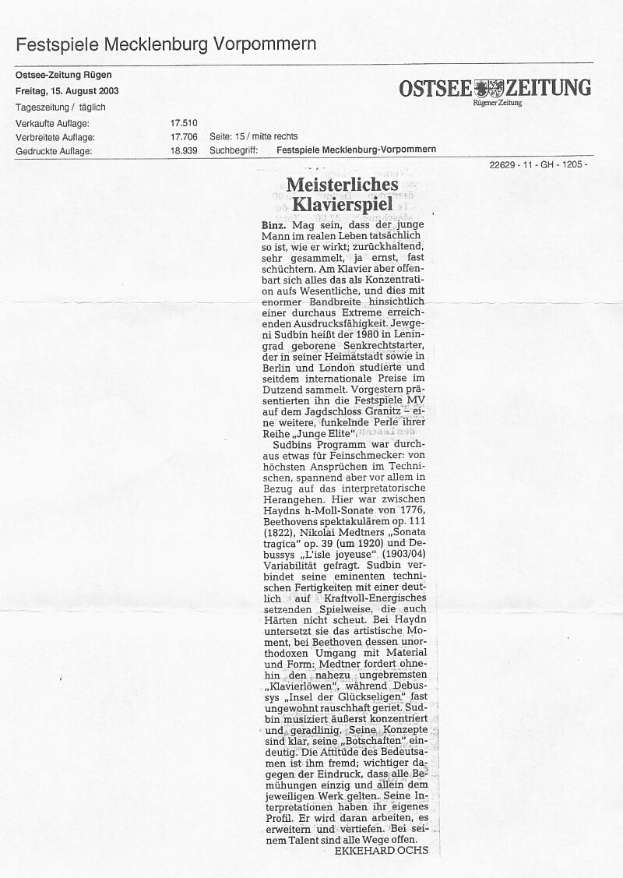

Translation:
Masterful
Piano Playing
Binz. It is possible that the young man may
actually be as he seems; reserved, very focused,
in fact quite serious and almost shy. But when
at the piano, a broad spectrum of intense
expressiveness is revealed through his
concentration on the essential in music.
Yevgeny Sudbin is the name of the new
uprising star, born in St.Petersburg (1980)
who studied in his home town as well as in
Berlin and London and since then has collected
dozens of international prizes. The Festival
Mecklenburg-Vorpommern presented him
at the Castle Granitz with a recital – yet
another lustrous pearl from their concert
series Young Elite.
Sudbin’s programme was something for music
connoisseurs: it made the highest demands in
virtuosity, but what was particularly gripping,
was his interpretational perception. An incredible
variety: from Haydn’s B minor Sonata (1776),
Beethoven’s spectacular op. 111 (1822),
Nikolai Medtner’s Sonata Tragica op. 39/5
(1920) and Debussy’s L’Isle Joyeuse (1904).
Sudbin unites his eminent technical skills with
a distinctive powerful-energetic playing. This is
what underlies the artistic conception in
Haydn and his unorthodox treatment of
material and form in Beethoven. Medtner
anyway demands well-nigh untamable “Lion
of the Piano” approach, while Debussy’s
L’Isle Joyeuse came across extraordinarily
ecstatic. Sudbin’s music-making is very focused
and direct. His concepts are clear and his
“message” unequivocal. Moreover, the
impression that all efforts are entirely devoted
to the specific work, is of most significance to
him. All Sudbin’s interpretations have their own
profile. He will continue to work, expand and
deepen his interpretations. With his talent, all
roads are open to him.

