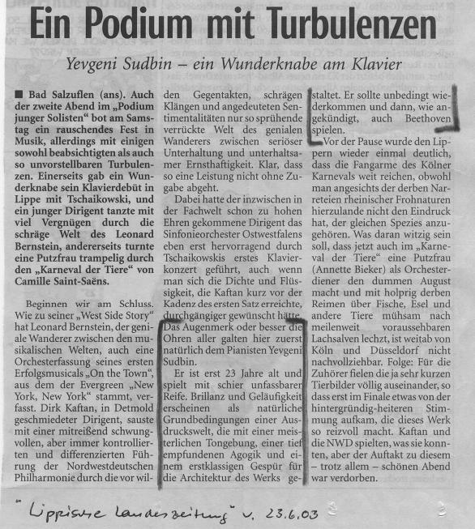

translation:

A Platform with Turbulences (Tchaikovsky’s 1st Piano Concerto)
…
The eyes, or better the ears of everyone in the audience were naturally fixed upon the pianist Yevgeny Sudbin in the first instance.
He is only 23 and plays with an absolutely unbelievable maturity. Brilliance and fluency seem as a natural prerequisite of a world of expression, that shape the entire work, with a masterly sound production, a deeply sensed Rubato (Agogic) and a first rate instinctive grasp of the works architecture.

