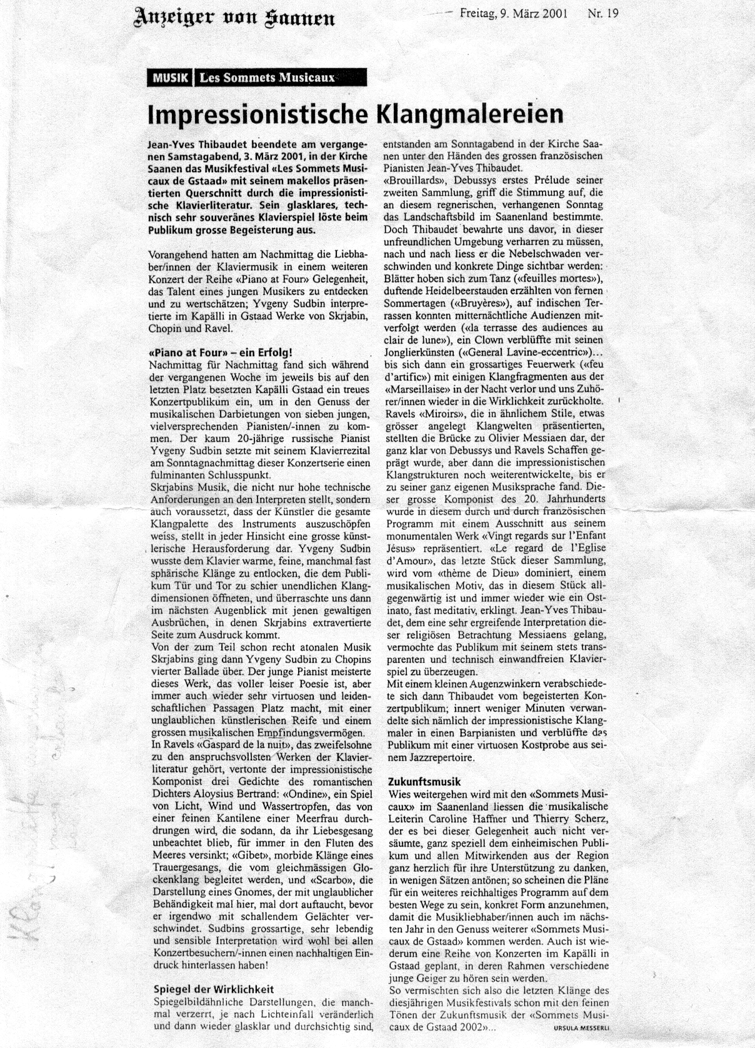
Translation from:
Anzeiger von Saanen Friday, March the 9th 2001

Music: Les Sommets Musicaux

…

In the afternoon, the piano-music enthusiasts had the opportunity to discover and appreciate the talent of a young musician during the concert series Piano at Four. In the Chapel of Gstaad, Yevgeny Sudbin interpreted pieces by Scriabin, Chopin and Ravel.

Piano at Four – a success!
…
With his piano recital on a Sunday afternoon, the young 20 year old Russian pianist Yevgeny Sudbin ended these concert series stunningly.
Scriabin’s music doesn’t only challenge the interpreter enormously from the technical point of view, but also demands a highly imaginative and colourful use of the entire palette of sound. Yevgeny Sudbin clearly knew how to bring out all the warm, tender, sometimes even cosmic sounds of the piano that opened up a gateway to pure, infinite spheres of existence for the audience, and he then immediately shocked us with those explosive outbursts emanating from Scriabin’s extraverted side.
From this already quite atonal Sonata by Scriabin, Y. Sudbin turned to Chopin’s 4th Ballade. The young pianist mastered this work, which is full of soft and tender poetry, but always allowing room for very virtuosic and passionate passages, with an unbelievable artistic maturity and a great musical sensitivity.
…
Yevgeny Sudbin’s excellent, very lively and sensitive interpretations will certainly have left a long-lasting impression on the audience!

