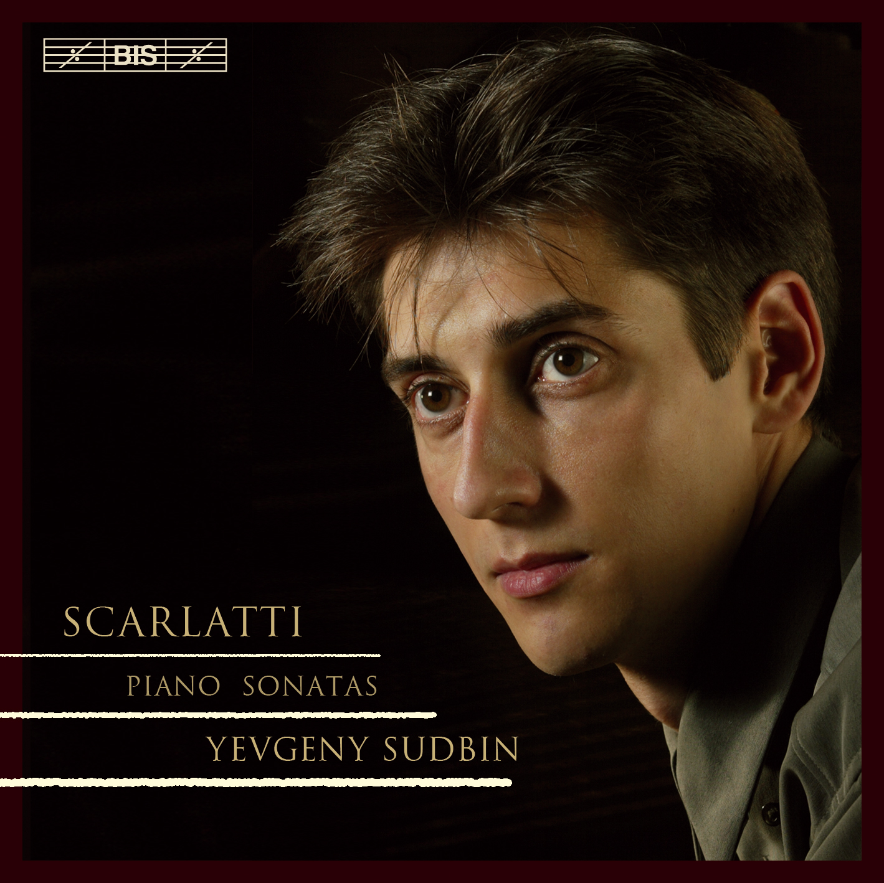
“A magnificent solo debut and a Scarlatti recital to rival the best”-
Editor's Choice, The Gramophone, May 2005
10/10 and Disc of the Month (April 2005), both ClassicsToday, USA and ClassicsToday, France

Classical CD of the Week, The Daily Telegraph 09/04/2005
"Yevgeny Sudbin makes his solo debut on disc with performances of a superlative vitality and super-fine sensitivity... This is, arguably, among the finest, certainly most enjoyable of all Scarlatti recitals." Bryce Morrison, The Gramophone, May 2005
”Once in a blue moon a record appears by a hitherto unknown artist who seems destined to take his place among the elect. Every note dazzles, enchants, seduces or moves one… the bravura fizzles like the best champagne. Both musically and technically, this debut is on a par with those two greatest of Scarlatti pianists, Horowitz and Pletnev. As eloquent in the most poignant sonatas as he is brilliant in the showstoppers, Sudbin is already a master.” Daniel Steans, Piano, March/April 2005
BIS-CD-1508: 18 Keyboard Sonatas TT: 75'45 Released: Jan 2005

“What bowls me over most is his sheer musicality. It shines out of every bar, and his playing has a constant sense of delighted discovery. As debut albums go, they don’t get much better than this” Harriet Smith, BBC Radio 3 CD Review, 12/03/2005
"This is absolutely great piano playing, and it's matched by one of the most beautiful keyboard recordings to come along in a quite a while. If you love Scarlatti – never mind the opportunity to make the acquaintance of a stellar young artist clearly capable of wonderful things – you simply must hear this." David Hurwitz ClassicsToday, USA (10/10 and Disc of the Month, April 2005)
“Yevgeny Sudbin stands out among his generation as a young pianist with great sensitivity, imagination and unusual insight.” Chloe Cutts, International Piano Magazine, March/April 2005

"Sudbin is a player of remarkable fire and fineness. Sudbin lends such ardour to the part-writing that each one seems a living thing." Paul Driver, The Sunday Times, 06/03/2005
“His playing has a wonderful fluency and easy style... A hugely promising beginning.” Andrew Clements, The Guardian 25/03/05
“Yevgeny Sudbin evokes a kaleidoscopic array of colours – He relishes the rumbustiousness and subversive wit of the fast numbers, and conjures wonderfully poetic sonorities…a dazzling debut recital.” Richard Wigmore, The Daily Telegraph 09/04/2005 (CD of the Week)
“in terms of aristocratic poise he matches even Michelangeli. Sudbin grips the listener with an almost Petrovian magnetism. This is staggering playing, so spontaneously alive that one can scarcely belive it was taped in the studio. In the wrong hands a little Scarlatti can go a long way, but when played like this one can easily imagine sitting through all 555 sonatas.” Julian Haylock, International Piano, March/April 2005
“there is an unusually profound, spiritual wonder.” L. Ferraccioli, Pianist, June/July 2005 (recommended)
“Sudbin has all the technical polish and artistic inspiration to become one of the great keyboard artists of the 21st Century.” Don Satz, ClassicalDigest, USA
International press: "Was [Sudbin] hier für Farben aus dem Steinway zaubert – beispielsweise die Glocken- und Harfen-Klänge in den hohen lagen – , wie kultiviert er trillert, in welch feinen Stufungen er die Dynamik einsetzt, das offenbart den Meister." G. Willmes, Fono Forum, April 2005
"Car Evgueni Sudbin est (positivement) fou! Ce qu'il fait ici, pour son premier disque me semble-t-il, est proprement incroyable d'intelligence, de pertinence et d'art pianistique (toucher, sonorité). Voilà l'un des grands disques de piano de 2005 et assurément le nouveau talent le plus remarquable de l'année." Christophe Huss, ClassicsToday, France (10/10 and Disc of the Month April 2005)
“Da sitzt einer am Steinway, der natürlich die Technik drauf hat und mit Geist und Intelligenz jeder dieser meist vierminütigen Miniaturen eine eigene Erscheinung geben kann. Mit Sudbin hat Scarlatti seinen Interpreten gefunden.” Thomas Vitzthum, Klassik.com, Germany
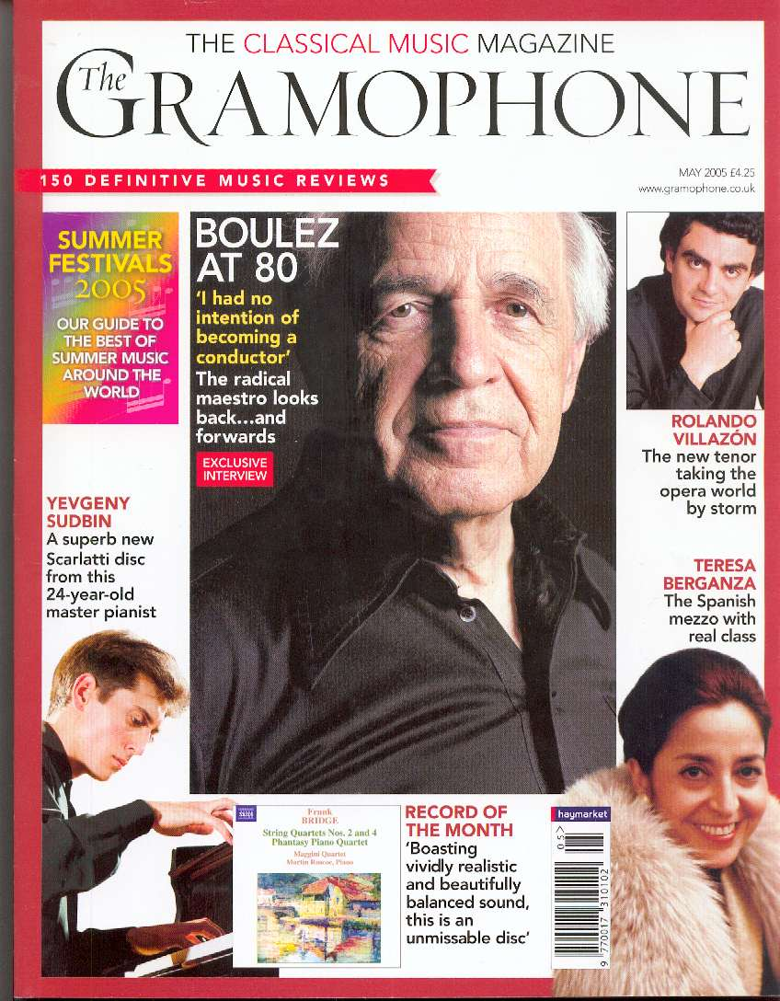
"Un pianiste de grande classe, totalement maître de ses moyens et possédant un charisme et une autorité qui font trop souvent défaut aux musiciens de sa géneration." Stephane Blet, Piano, France, April 2005

