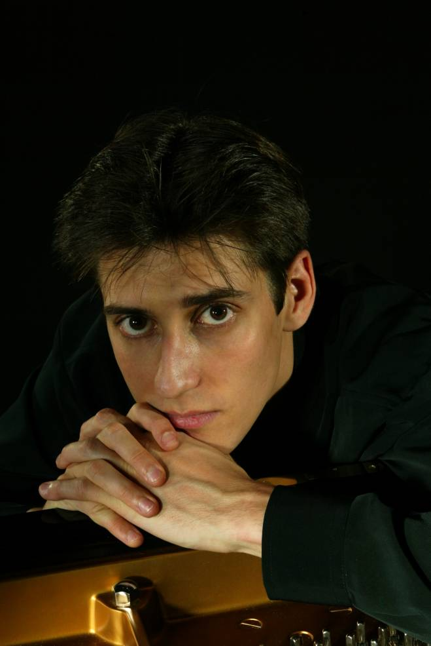
Born in St Petersburg in 1980, Yevgeny Sudbin displayed exceptional musical talents from an early age and in 1987 entered the specialist music school of the St Petersburg Conservatory, where he became a pupil of Lyubov Pevsner. In 1990 he continued his studies at the Hochschule Hanns Eisler in Berlin. Yevgeny has lived in London since 1997, where he studies with Christopher Elton at the Royal Academy of Music. Additionally, Yevgeny pursues his studies at the International Piano Foundation at Lake Como, Italy. He has also had lessons from musicians including Murray Perahia, Claude Frank, Leon Fleisher, Stephen Kovacevich, Dmitri Bashkirov, Fou Ts’Ong, Stephen Hough, Alexander Satz, and Maria Curcio.

Yevgeny has gained first prizes at numerous international competitions including the Young Virtuosi International Piano Competition (ČR), Concertino Praga (ČR) and the Vendôme Prize, London. He has also been the recipient of the Alfred Brendel Prize, Hattori, Myra Hess awards and the Orpheum Public Award after a performance with the London Mozart Players in the Tonhalle (Zürich). The Pulvermacher Foundation and the Wall Trust have also played an important role in Yevgeny’s career.

Yevgeny has performed extensively throughout Germany, the UK, Italy, Switzerland, France and the USA. His frequent performances with distinguished orchestras – many of which have been broadcast on radio and television – have received high critical acclaim. These have included engagements with the National Symphony Orchestra of Ireland, the Philharmonie in Cologne with the Radio Symphony Orchestra under Hans Vonk, BBC Scottish Symphony Orchestra, the Gewandhaus in Leipzig, the Schauspielhaus in Berlin, Paris Chamber Orchetsra and the Nordwestdeutsche Philharmonie Orchestra in Hanover. He performs regularly with the London Octave Orchestra, with whom he has recorded a CD of works including Bach’s D minor Keyboard Concerto. He has given recitals in series at the Serate Musicali (Milan), London’s Southbank, Musikhalle in Hamburg and at festivals such as Nuits Romantiques in France and the Verbier Festival (Switzerland).

He is also keenly committed to chamber music, performing regularly with violinist Ilya Gringolts, and has collaborated with the Chilingirian String Quartet and Julia Fischer.

His Wigmore Hall debut was hailed by The Independent as: ‘A great recital. He is a pianist of uncommon sensitivity and refinement and has total confidence in his imaginative concept of each piece.’ His debut CD of Scarlatti sonatas, the first of several projected CDs for the BIS label, was recently released to huge critical acclaim worldwide and has resulted in an exclusive five-year contract with BIS. The recording was an Editor’s Choice in The Gramophone who, describing him as ‘a master pianist’, featured him on their front cover: ‘This is arguably among the finest, certainly most enjoyable of all Scarlatti recitals.’ (Bryce Morrison, The Gramophone). His second recording, a Rachmaninov recital, is due to be released later this year.

